Arts Camp 2012
Ages 3rd grade - Adult
July 23- July 26, 6-8 PM
Intergenerational, Multicultural and Interfaith: All Welcome!
drawing Papermaking CardMaking

printmaking collage

Opening Spaghetti Dinner July 23 at 5 PM
Closing Sub Sandwich Dinner July 26 at 5 PM

Ice Cream Social and Art Opening Saturday, July 28, 1-3 PM
God saw everything…and indeed, it was very good! -Genesis 1:31

First Presbyterian Church of Troy, 4328 Livernois Road

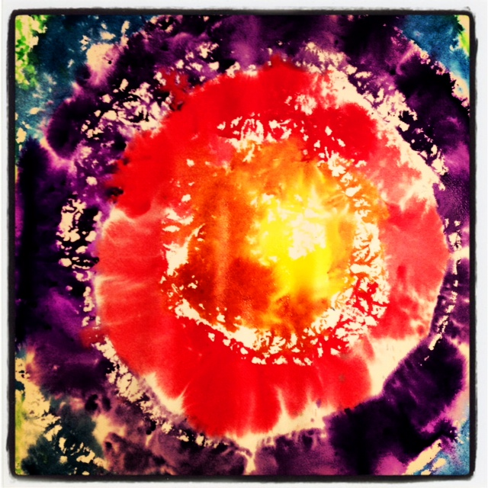

Please Register using the back of this page
Limited Space for 25, all basic supplies included, you may bring scrap fabric, buttons or beads for your collage and images found in nature for inspiration!
This event is free and open to the public!
Donations of juice and tea are welcome for our snack table.

Sponsored by a grant through the Presbytery of Detroit Peacemaking Committee

