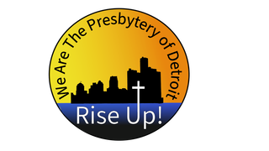

The Presbytery of Detroit

FAITH IN ACTION
Track 3 GRANT APPLICATION

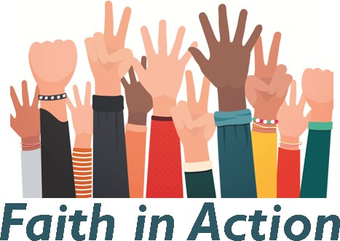

Application Due Date: February 28, 2022

Submit Applications: faithinaction@detroitpresbyerty.org
Note: No mailed in applications will be accepted

Approval Date: March 2022
Disbursement Date: April 2022
Final Report Date: June 2023

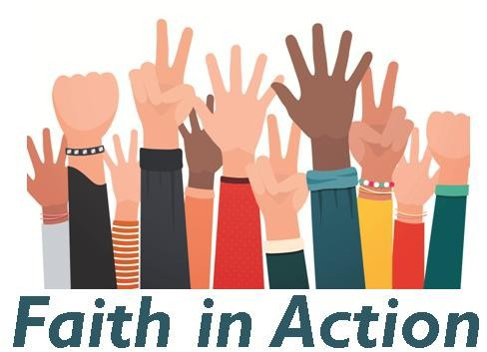
Applicant Cover Sheet
Project Manager (or co-manager, if done in partnership): Congregation (and partners, if applicable):
Address: Phone: Email:
Total Amount Requested:
Payee (to whom should the check be written): Federal Tax ID (if applicable):

Name of Project/Ministry:
In no more than two sentences, write a summary of the overall purpose of the project:

Project Start Date: Project End Date:

(Leave area blank for grant committee comments)

Faith in Action,

Track 3 Background Information
Centering Scripture:
In the times we feel most scattered and worried about our future, we often turn our attention inward. God assures us though that our welfare and well-being is tied to the well-being of others.
In the Gospel of Matthew, Jesus tells his disciples to “Seek first the kingdom of God and God’s righteousness and all these things will be given to you as well.” (Matthew 6:33). Throughout Matthew, Jesus gives us a glimpse of what this kingdom looks like, including in Matthew 25: “Then the king will say… ‘for I was hungry and you gave me food, I was thirsty and you gave me something to drink, I was a stranger and you welcomed me, I was naked and you gave me clothing, I was sick and you took care of me, I was in prison and you visited me.’”
How will we, in this new time, continue to seek first the kingdom of God?
Introduction:
This $300,000 gift is, once again, from an anonymous donor who has been involved with and has supported the Presbyterian Church for over 50 years. God, through God’s amazing grace, has tasked the donor with providing funding to improve mission capabilities and results of congregations and their mission partners within the Presbytery of Detroit (POD). The funds will help the presbytery seek God’s kingdom in our communities during this coming year. This is the third major gift given by this donor to the POD (also in 2018 and 2020).
The donor wishes to continue to invest in a presbytery-wide program that incubates/prepares new types of mission work, energizes existing mission initiatives to achieve new levels of faith in action, and responds to mission requests that need urgent attention. Creating hope where hope struggles and creating new capabilities within the POD is important. The intent is to establish a portfolio of mission requests that not only improve hope and mission capabilities in the short term but to create and establish more effective mission programs/ initiatives that fulfill God’s calls and will in the future. This portfolio can be updated to address special needs and unforeseen circumstances that arise. Hopefully, some of the latter initiatives will be new attempts and methods to bring God’s love and grace to the communities within the POD.
Rev. Julie Delezenne and Rev. Emma Nickel have been designated by the donor to be the organizing voices for this donation. They, working with other mission leaders in the POD, will define, create/delegate and distribute the funding packages throughout the presbytery. This group will decide priorities, phasing of donations, and accountability to spend the money according to God’s will and purpose. The Trustees of the POD will review these guidelines and have final approval of the disbursement of funds.

Funding for Programs That Embody the Matthew 25 Vision ($180,000 total)
The Matthew 25 vision of PCUSA charges each of us in each of the three areas below to “actively engage the world around us” by:
1. Building congregational vitality
2. Dismantling structural racism
3. Eradicating systemic poverty
See more about Matthew 25 at: https://www.presbyterianmission.org/ministries/matthew-25/
Guidelines:
- Funded programs in this track will be focused on bringing the vision of Jesus’ words in Matthew 25 as well as the PC(USA) Matthew 25 vision into reality in our communities.
- The focus is on congregations and their mission partners doing the work of God, as guided by Scripture, in the communities of the POD. It is not intended to fund nor improve day-to-day operations of the on-going church community.
- Programs, projects, tasks, and activities that are approved for funding are intended to fall within three categories:
a. incubates/prepares new types of mission work
b. energizes existing mission initiatives to achieve new levels of faith in action
c. responds to mission requests that need urgent attention

Who can apply for funds?

- Congregations of the POD
- POD Congregations partnering together or with other faith communities
- Approved ECO (Extra Commitment Opportunity) organizations in partnership with POD congregations

Questions:
- Can any of this donation be used to match other mission donations to create more compelling mission programs? YES! Using the donation as an enabler for additional growth in missions is a great idea.

- Can any of the donation be distributed to churches in need to support mission based upon urgent needs? YES! Using the donation through a discretionary package to a responsible leader in the area of urgent need is within the scope of the donation. Accountability for discretionary distributions needs to be held at the church leadership level.

- Are new approaches at mission giving to fulfill God’s will acceptable? YES! With a belief that God leads us in new paths to fulfill God’s calling to us, this is not only acceptable but encouraged.

- Could this be used by churches to support international missions/projects with whom they are involved? Yes; however, the international component should be a minor part of the overall portfolio; the majority of the portfolio should be for within the geographical boundaries of the Presbytery.

If you have questions about the application process, please email: faithinaction@detroitprebytery.org

The Faith in Action Work Group
Rev. Julie Delezenne, Co-Chair, Warren First
Rev. Emma Nickel, Co-Chair, Royal Oak First
Deacon Michael Kim, New Hope
Elder Loretta Stanton, Fort Street Detroit
Rev. Dr. Flo Barbee Watkins, TGP

IMPORTANT DATES:
APPLICATION DUE DATE: February 28, 2022
Approval Date: March 2022 Disbursement Date: April 2022

Submit Applications: faithinaction@detroitpresbyerty.org.
Note: No mailed in applications will be accepted

Use the checklist below to guide you through the application process and the required information to accompany the application

I. Church Sponsored Projects | II. Churches in Partnership with Non-profit 501(c)3 Corporations (ECOS):
Session approval w/ minutes. | Session approval w/minutes of partnership & project approval.
Mission Statement of non-profit

Board of Directors approval of partnership & project approval.
Clerk of Session signature on project application | Clerk of Session signature on project application.
 | Board Chairperson signature on project application.
Detailed budget for each project year. Attach. | Detailed budget for each project year. Attach.

Please complete the following questions:
- Who is/are the group(s) we are hoping to serve/be in partnership with for this project? Be specific.

- Goals of the Project: What need or problem is being addressed?

- List three to five specific outcome objectives of the program to be funded. Describe the beneficial results of the program. Tell WHO is going to do WHAT, HOW MUCH will be done and HOW it will be measured. State results, not activities.

- List how your church or nonprofit has worked with the target community in the past.

- How does this project meet the purpose of the grant (Page 3,4, Guidelines)? (250 word limit)

- List the specific ways the congregation will participate in the project.

- Include a detailed budget for the project per the instructions on checklist.

- What other funding sources have your requested or secured?

- Detail your plan for assessing the project.

To be completed after grant is awarded:

- End of Project report: Due June 2023
- Assess how each objective achieved.
- How has this inspired you to continue working in this community?
- What impact has this program in your congregation’s spiritual journey?
- What from your experience would you want to share with another church that is seeking to serve its community?
- Please submit final project financials (in Excel).

REQUIRED SIGNATURES

CHURCH SPONSORED PROJECTS

Signature of Project Leader: Date: Signature of Clerk of Session: Date:

CHURCHES IN PARTNERSHIP WITH 501 ( C ) 3 NON-PROFIT CORPORATIONS (ECOS):

Signature of Clerk of Session: Date: Signature of Board Chair: Date: Signature of Project Leader: Date:

Date of draft: 10.26.2021

